# Java快速入门

## 1- 介绍

## 2- 创建一个工程

首先，我们使用Eclipse（注意就是Eclise，如果没有安装好，选安装好再接着下一个步骤）创建一个新的项目，这将在本教程中使用。

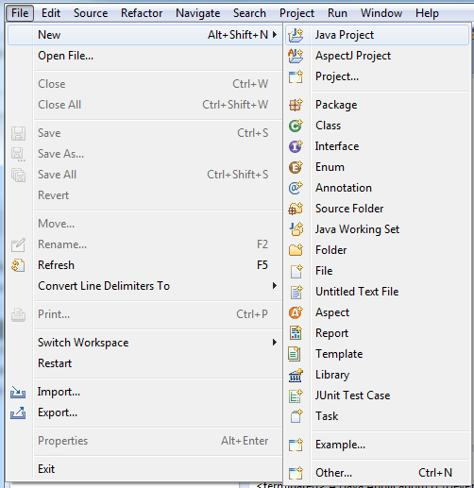  
输入项目名称：

* **BasicJavaTutorial**

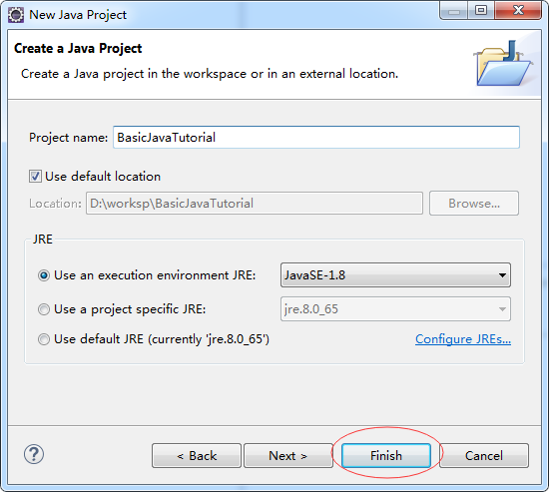  
项目已创建：  
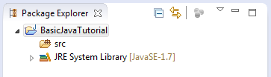

注：为了能够在除英语工程其他语言可以使用，应该切换到UTF-8编码。

右键单击该项目并选择属性：  
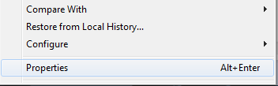  
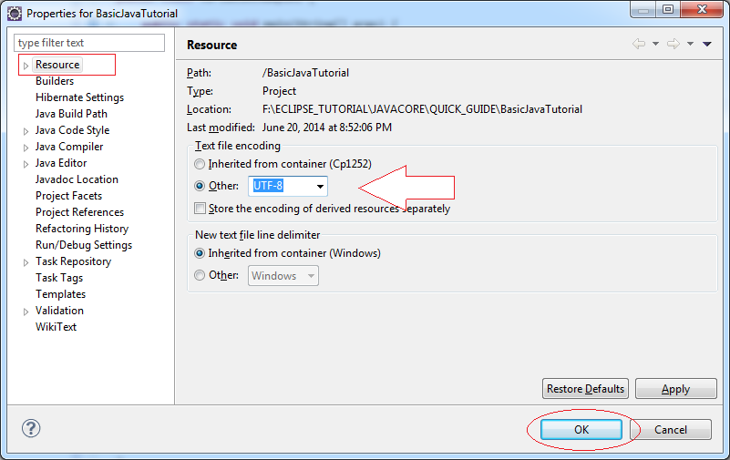

## 3- 原始数据类型

JAVA中有八种基本类型

* 对于整数有4种类型：**byte, short, int, long**
* 实数类型：**float, double**
* 字符类型： **char**
* 布尔： 返回 **true** 或 **false** 值 (true 或 false)

|  |  |  |  |  |
| --- | --- | --- | --- | --- |
| **类型** | **描述** | **bit** | **最小值** | **最大值** |
| byte | 8位整数 | 8 | -128 (-2^7) | 127 (2^7-1) |
| short | 16位整数 | 16 | -32,768 (-2^15) | 32,767 (2^15 -1) |
| int | 32位整数 | 32 | - 2,147,483,648 (-2^31) | 2,147,483,647 (2^31 -1) |
| long | 64位整数 | 64 | -9,223,372,036,854,775,808 (-2^63) | 9,223,372,036,854,775,807 (2^63 -1) |
| float | 32位实数 | 32 | -3.4028235 x 10^38 | 3.4028235 x 10^38 |
| double | 64位实数 | 64 | -1.7976931348623157 x 10^308 | 1.7976931348623157 x 10^308 |
| boolean | 逻辑类型 |  | false | true |
| char | 字符 | 16 | '\u0000' (0) | '\uffff' (65,535). |

## 4- 变量

右键点击 **src**并选择 "**New/Package**":  
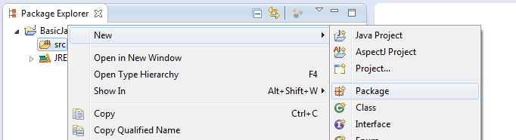

新建命名包是：

* com.yiibai.tutorial.javabasic.variable  
  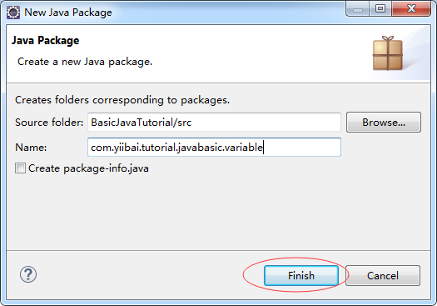

选择上面创建的包名 com.yiibai.tutorial.javabasic.variable，在弹出的菜单中选择 New 中选择 Class。

输入类的名称：

* **VariableExample1  
  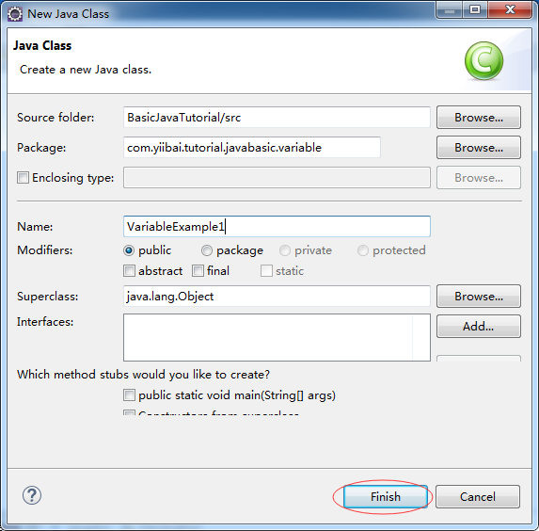**

创建 VariableExample1 类如下：

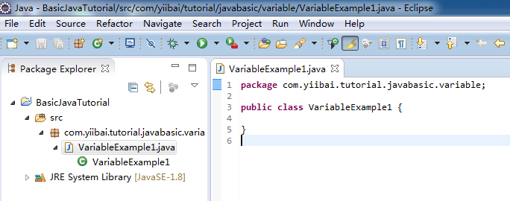

* **VariableExample1.java**

package com.yiibai.tutorial.javabasic.variable;

public class VariableExample1 {

public static void main(String[] args) {

// Declare a variable of type int (integer 32-bit)

int firstNumber;

// Assigning values to firstNumber

firstNumber = 10;

System.out.println("First Number =" + firstNumber);

// Declare a 32-bit real number (float)

// This number is assigned a value of 10.2

float secondNumber = 10.2f;

System.out.println("Second Number =" + secondNumber);

// Declare a 64-bit real numbers

// This number is assigned a value of 10.2

// character d at the end to tell with Java this is the type double.

// Distinguished from a float.

double thirdNumber = 10.2d;

System.out.println("Third Number =" + thirdNumber);

// Declare a character

char ch = 'a';

System.out.println("Char ch= " + ch);}

}

运行类 **VariableExample1**:

在 VariableExample1 类右键单击选择 "Run As/Java Application"：  
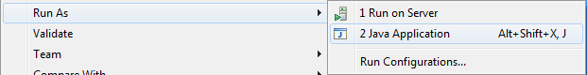

运行类，在控制台上看到的结果如下：  
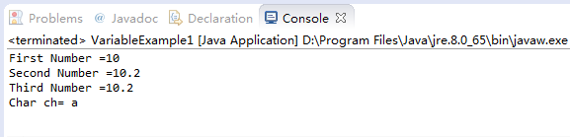

您也可以一次声明多个变量，下例说明了这一点：

创建一个新的类 **VariableExample2  
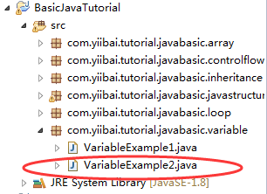**

* **VariableExample2.java**

package com.yiibai.tutorial.javabasic.variable;

public class VariableExample2 {

public static void main(String[] args) {

// Declare three 64-bit integer (long)

long firstNumber, secondNumber, thirdNumber;

// Assign value to firstNumber

// L at the end to tell java a long type, distinguished from type int.

firstNumber = 100L;

// Assign values to secondNumber

secondNumber = 200L;

// Assign values to thirdNumber

thirdNumber = firstNumber + secondNumber;

System.out.println("First Number = " + firstNumber);

System.out.println("Second Number = " + secondNumber);

System.out.println("Third Number = " + thirdNumber);

}

}

运行类 VariableExample2 的结果 :  
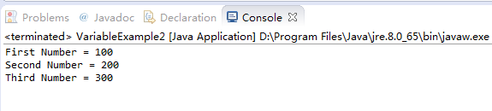

## 5- 控制流

## 5.1- if-else语句

if-else 语句的结构是：

if(condition1 true) {

// Do something here

}elseif(condition2 true) {

// Do something here

}elseif(condition3 true) {

// Do something here

}else { // Other

// Do something here

}

创建一个类 ElseIfExample1:  
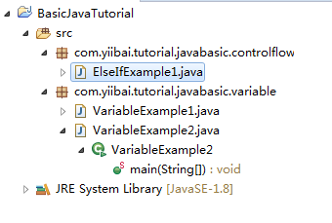

* **ElseIfExample1.java**

package com.yiibai.tutorial.javabasic.controlflow;

public class ElseIfExample1 {

public static void main(String[] args) {

// Declaring a integer number (int)

int score = 20;

System.out.println("Your score =" + score);

// If the score is less than 50

if (score < 50) {

System.out.println("You are not pass");

}

// Else if the score more than or equal to 50 and less than 80.

else if (score >= 50 && score < 80) {

System.out.println("You are pass");

}

// Remaining cases (that is greater than or equal to 80)

else {

System.out.println("You are pass, good student!");

}

}

}

运行 ElseIfExample1 类的结果：  
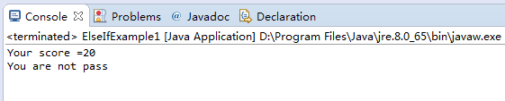

改变在上面的例子中，变量“score”的值，然后重新运行ElseIfExample1类：

int score = 80;

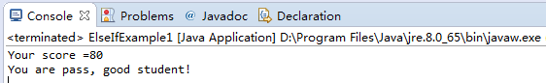

## 5.2- 常规操作符

* > 大于号
* < 小于号
* >= 大于或等于
* <= 小于或等于
* && 且
* || 或
* == 等一个值
* != 不等于一个值
* ! 非

创建一个类 **ElseIfExample2**

* **ElseIfExample2.java**

package com.yiibai.tutorial.javabasic.controlflow;

public class ElseIfExample2 {

public static void main(String[] args) {

// Declare a variable int simulate your age.

int age = 20;

// Test age less than or equal 17

if (age <= 17) {

System.out.println("You are 17 or younger");

}

// Test age equals 18

else if (age == 18) {

System.out.println("You are 18 year old");

}

// Test age, greater than 18 and less than 40

else if (age > 18 && age < 40) {

System.out.println("You are between 19 and 39");

}

// Remaining cases (Greater than or equal to 40)

else {

// Nested if statements

// Test age not equals 50.

if (age != 50) {

System.out.println("You are not 50 year old");

}

// Negative statements

if (!(age == 50)) {

System.out.println("You are not 50 year old");

}

// If age is 60 or 70

if (age == 60 || age == 70) {

System.out.println("You are 60 or 70 year old");

}

}

}

}

您可以修改 “age” 的值，然后重新运行 ElseIfExample2 类，并查看结果。

## 5.3- 布尔值

布尔是一种数据类型，它只有两个值true或false。

创建一个类 **BooleanExample**

* **BooleanExample.java**

package com.yiibai.tutorial.javabasic.controlflow;

public class BooleanExample {

public static void main(String[] args) {

// Declare a variable of type boolean

boolean value = true;

// If value is true

if (value == true) {

System.out.println("It's true");

}

// Else

else {

System.out.println("It's false");

}

// With boolean values you can also write

if (value) {

System.out.println("It's true");

}

// Else

else {

System.out.println("It's false");

}

}

}

## 5.4- switch- case -default 语句

这也是类似上面介绍的 if-else 分支语句：

switch( variable_to_test ) {

casevalue:

// code_here;

break;

casevalue:

// code_here;

break;

default:

// values_not_caught_above;

}

* SwitchExample1.java

package com.yiibai.tutorial.javabasic.controlflow;

public class SwitchExample1 {

public static void main(String[] args) {

// Declare a variable age

int age = 20;

// Check the value of age

switch (age) {

// Case age = 18

case 18:

System.out.println("You are 18 year old");

break;

// Case age = 20

case 20:

System.out.println("You are 20 year old");

break;

// Remaining cases

default:

System.out.println("You are not 18 or 20 year old");

}

}

}

运行类 SwitchExample1 的结果 :

You are 20 year old

请注意case语句是一个特定的值，不能做下面的操作：

// This is not allowed !!

case(age < 18) :

// case only accept a specific value eg:

case18:

// Do something here

break;

看下面的一个例子：

* **SwitchExample2.java**

package com.yiibai.tutorial.javabasic.controlflow;

public class SwitchExample2 {

public static void main(String[] args) {

// Declare a variable age

int age = 30;

// Check the value of age

switch (age) {

// Case age = 18

case 18:

System.out.println("You are 18 year old");

// Case age in 20, 30, 40

case 20:

case 30:

case 40:

System.out.println("You are " + age);

break;

// Remaining case:

default:

System.out.println("Other age");

}

}

}

运行结果：

You are 30

## 5.5- for循环

语法：

for( start_value; end_value; increment_number ) {

// Code here

}

考虑如下一个例子：

* **ForLoopExample1.java**

packagecom.yiibai.tutorial.javabasic.loop;

publicclass ForLoopExample1 {

publicstaticvoidmain(String[] args) {

// Declare a variable, step in loop

intstep = 1;

// Declare a variable value with the start value is 0

// After each iteration, value will increase 3

// And the loop will end when the value greater than or equal to 10

for(intvalue = 0; value < 10; value = value + 3) {

System.out.println("Step ="+ step + " value = "+ value);

// Increase 1

step = step + 1;

}

}

}

运行 **ForLoopExample1**类结果：

Step =1 value = 0

Step =2 value = 3

Step =3 value = 6

Step =4 value = 9

另一实例中，从1至100的数字求和：

* ForLoopExample2.java

package com.yiibai.tutorial.javabasic.loop;

public class ForLoopExample2 {

public static void main(String[] args) {

int sum = 0; for (int i = 0; i <= 100; i = i + 1) {

sum = sum + i;

}

System.out.println(sum); }

}

结果：

5050

## 5.6- while循环

这是 while 循环结构：

// While the condition is true, then do something.

while( 条件为真 ) {

// Do something here.

}

参见图示

* WhileExample1.java

publicclassWhileExampe1 {

publicstaticvoidmain(String[] args) {

int value = 3;

// While the value is less than 10, the loop is working.

while( value < 10) {

System.out.println("Value = "+ value);

// Increase value by adding 2

value = value + 2;

}

}

}

## 5.7- do-while循环

下面是do-while循环的结构：

// The do-while loop to work at least one round

// and while the condition is true, it also works to

do{

// Do something here.

}while( condition );

如下图的示例：

* DoWhileExample1.java

package com.yiibai.tutorial.javabasic.loop;

public class DoWhileExample1 {

public static void main(String[] args) {

int value = 3;

// do-while loop will execute at least once

do {

System.out.println("Value = " + value);

// Increase 3

value = value + 3;

} while (value < 10);

}

}

结果：

Value = 3

Value = 6

Value = 9

## 6- Java数组

## 6.1- 什么是数组？

数组是元素存储在彼此相邻列表。

让我们来看看，一个数组有5个int型的元素。

## 6.2- 使用数组

如何在Java中声明数组。

// Declare an array, not a specified number of elements.

int[] array1;

// Initialize the array with 100 elements

// The element has not been assigned a specific value

array1 = new int[100];

// Declare an array specifies the number of elements

// The element has not been assigned a specific value

double[] array2 = new double[10];

// Declare an array whose elements are assigned specific values.

// This array with 4 elements

long[] array3= {10L, 23L, 30L, 11L};

让我们来看一个例子：

* ArrayExample1.java

package com.yiibai.tutorial.javabasic.array;

public class ArrayExample1 {

public static void main(String[] args) {

// Declare an array with 5 elements

int[] myArray = new int[5];

// Note: the first element of the array index is 0:

// Assigning values to the first element (index 0)

myArray[0] = 10;

// Assigning values to the second element (index 1)

myArray[1] = 14;

myArray[2] = 36;

myArray[3] = 27;

// Value for the 5th element (the last element in the array)

myArray[4] = 18;

// Print out element count.

System.out.println("Array Length=" + myArray.length);

// Print to Console element at index 3 (4th element in the array)

System.out.println("myArray[3]=" + myArray[3]);

// Use a for loop to print out the elements in the array.

for (int index = 0; index < myArray.length; index++) {

System.out.println("Element " + index + " = " + myArray[index]);

}

}

}

结果：

Array Length=5

myArray[3]=27

Element 0 = 10

Element 1 = 14

Element 2 = 36

Element 3 = 27

Element 4 = 18

举一个实例来说明使用一个for循环来对元素赋值：

* ArrayExample2.java

package com.yiibai.tutorial.javabasic.array;

public class ArrayExample2 {

public static void main(String[] args) {

// Declare an array with 5 elements

int[] myArray = new int[5];

// Print out element count

System.out.println("Array Length=" + myArray.length);

// Using loop assign values to elements of the array.

for (int index = 0; index < myArray.length; index++) {

myArray[index] = 100 * index * index + 3;

}

// Print out the element at index 3

System.out.println("myArray[3] = "+ myArray[3]);

}

}

输出结果：

Array Length=5

myArray[3] = 903

## 7- 类, 继承, 构造器

有三个概念需要进行区分：

* 类
* 构造
* 继承

当我们讨论树，它是抽象的东西，它是一个类。但是，当我们指出了一个特定的树（比如：槟榔树），很明显，那就是实例。

或者，当我们谈论的人，这是抽象的，它是一个类。但是，当指向你或我，这是两种不同的情况下，都是同一个 Person 类。

* **Person.java**

package com.yiibai.tutorial.javabasic.javastructure;

public class Person {

// This is field

// The name of Person

public String name;

// This is a Constructor

// Use it to initialize the object (Create new object)

// This constructor has one parameter

// Constructor always have the same name as the class.

public Person(String persionName) {

// Assign the value of the parameter into the 'name' field

this.name = persionName;

}

// This method returns a String ..

public String getName() {

return this.name;

}

}

Person类没有任何main函数。 TestPerson类通过构造函数初始化Person对象实例

* **PersonTest.java**

package com.yiibai.tutorial.javabasic.javastructure;

public class PersonTest {

public static void main(String[] args) {

// Create an object of class Person

// Initialize this object via constructor of class Person

// Specifically, Edison

Person edison = new Person("Edison");

// Class Person has the method getName()

// Use the object to call getName():

String name = edison.getName();

System.out.println("Person 1: " + name);

// Create an object of class Person

// Initialize this object via constructor of class Person

// Specifically, Bill Gates

Person billGate = new Person("Bill Gates");

// Class Person has field name (public)

// Use objects to refer to it.

String name2 = billGate.name;

System.out.println("Person 2: " + name2);

}

}

运行示例的结果如下：

Person 1: Edison

Person 2: Bill Gates

## 8- 字段

在本节中，我们将讨论一些概念：

字段

* 一般字段
* 静态字段
* final字段
* static final 字段

下面看看字段和静态字段的例子。

* FieldSample.java

package com.yiibai.tutorial.javabasic.javastructure;

public class FieldSample {

// This is static field.

public static int MY_STATIC_FIELD = 100;

// This is normal field.

public String myValue;

// Constructor

public FieldSample(String myValue) {

this.myValue= myValue;

}

}

* FieldSampleTest.java

package com.yiibai.tutorial.javabasic.javastructure;

public class FieldSampleTest {

public static void main(String[] args) {

// Create the first object.

FieldSample obj1 = new FieldSample("Value1");

System.out.println("obj1.myValue= " + obj1.myValue);

// Print out static value, access via instance of class (an object).

System.out.println("obj1.MY_STATIC_FIELD= " + obj1.MY_STATIC_FIELD);

// Print out static value, access via class.

System.out.println("FieldSample.MY_STATIC_FIELD= "

+ FieldSample.MY_STATIC_FIELD);

// Create second object:

FieldSample obj2 = new FieldSample("Value2");

System.out.println("obj2.myValue= " + obj2.myValue);

// Print out static value, access via instance of class (an object)

System.out.println("obj2.MY_STATIC_FIELD= " + obj2.MY_STATIC_FIELD);

System.out.println(" ------------- ");

// Set new value for static field.

// (Or using: FieldSample.MY_STATIC_FIELD = 200)

obj1.MY_STATIC_FIELD = 200;

// It will print out the value 200.

System.out.println("obj2.MY_STATIC_FIELD= " + obj2.MY_STATIC_FIELD);

}

}

运行示例的结果：

obj1.myValue= Value1

obj1.MY_STATIC_FIELD= 100

FieldSample.MY_STATIC_FIELD= 100

obj2.myValue= Value2

obj2.MY_STATIC_FIELD= 100

-------------

obj2.MY_STATIC_FIELD= 200

最后一个字段是不能一个新值分配给它的，它就像一个常数。

* **FinalFieldExample.java**

package com.yiibai.tutorial.javabasic.javastructure;

public class FinalFieldExample {

// A final field.

// Final Field does not allow to assign new values.

public final int myValue = 100;

// A static final field.

// Final field does not allow to assign new values.

public static final long MY_LONG_VALUE = 1234L;

}

## 9- 方法

有关方法的种类：

* 方法
* 静态方法
* final 方法 (将在类的继承中说明)
* MethodSample.java

package com.yiibai.tutorial.javabasic.javastructure;

public class MethodSample {

public String text = "Some text";

// Default Constructor

public MethodSample() {

}

// This method return a String

// and has no parameter.

public String getText() {

return this.text;

}

// This is a method with one parameter String.

// This method returns void (not return anything)

public void setText(String text) {

// this.text reference to the text field.

// Distinguish the text parameter.

this.text = text;

}

// Static method

public static int sum(int a, int b, int c) {

int d = a + b + c;

return d;

}

}

* MethodSampleTest.java

package com.yiibai.tutorial.javabasic.javastructure;

public class MethodSampleTest {

public static void main(String[] args) {

// Create instance of MethodSample

MethodSample obj = new MethodSample();

// Call getText() method

String text = obj.getText();

System.out.println("Text = " + text);

// Call method setText(String)

obj.setText("New Text");

System.out.println("Text = " + obj.getText());

// Static method can be called through the class.

// This way is recommended. (**)

int sum = MethodSample.sum(10, 20, 30);

System.out.println("Sum 10,20,30= " + sum);

// Or call through objects

// This way is not recommended. (**)

int sum2 = obj.sum(20, 30, 40);

System.out.println("Sum 20,30,40= " + sum2);

}

}

执行上面的程序输出结果如下：

Text = Some text

Text = New Text

Sum 10,20,30= 60

Sum 20,30,40= 90

## 10- 在Java中的继承

Java允许从其他类扩展类。类扩展另一个类称为子类。 子类必须有继承父类中的字段和方法的能力。

* Animal.java

package com.yiibai.tutorial.javabasic.inheritance;

public class Animal {

public Animal() {

}

public void move() {

System.out.println("Move ...!");

}

public void say() {

System.out.println("<nothing>");

}

}

* Cat.java

package com.yiibai.tutorial.javabasic.inheritance;

public class Cat extends Animal {

// Override method of the Animal class.

public void say() {

System.out.println("I am Cat");

}

}

* Dog.java

package com.yiibai.tutorial.javabasic.inheritance;

public class Dog extends Animal {

// Override method of the Animal class.

public void say() {

System.out.println("I am Dog");

}

}

* Ant.java

package com.yiibai.tutorial.javabasic.inheritance;

public class Ant extends Animal {

}

* AnimalTest.java

package com.yiibai.tutorial.javabasic.inheritance;

public class AnimalTest {

public static void main(String[] args) {

// Declaring a Cat object.

Cat cat = new Cat();

// Check 'cat' instance of Animal.

// The result is clearly true.

boolean isAnimal = cat instanceof Animal;

System.out.println("cat instanceof Animal?"+ isAnimal);

// ==> Meo

// Call the method say() of the Cat.

cat.say();

// Declare an object Animal

// Initialize the object through the Constructor of the Cat.

Animal cat2 = new Cat();

// ==> Meo

// Call to say() of Cat (Not Animal)

cat2.say();

// Create the object Animal

// Through the Constructor of the class Ant.

Animal ant = new Ant();

// Ant has no say() method.

// It call to say() method that inherited from the parent class (Animal)

ant.say();

}

}

运行示例的结果如下：

cat instanceof Animal?true

I am Cat

I am Cat

<nothing>